JAVA 8

Write the following a functional interface and implement it using lambda:

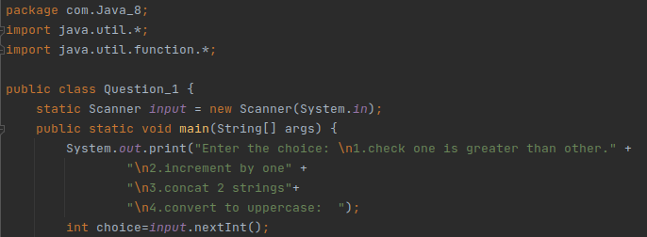

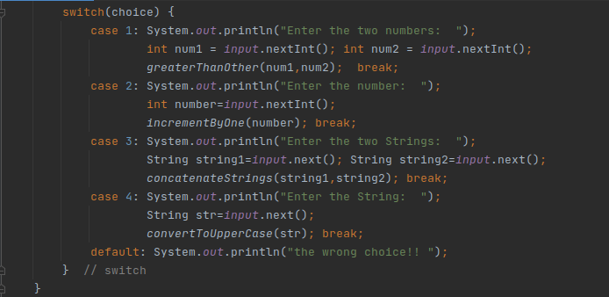

(1) First number is greater than second number or not Parameter (int ,int ) Return boolean::

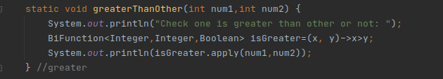

Output: 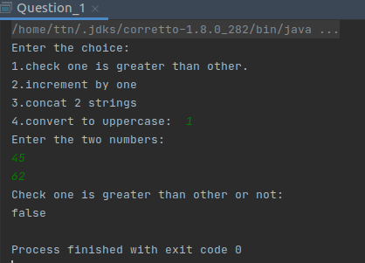

(2) Increment the number by 1 and return incremented value Parameter (int) Return int ::

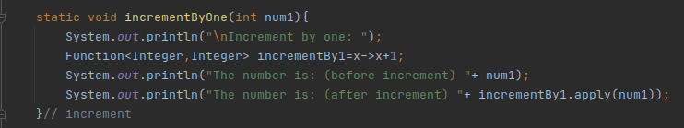

Output: 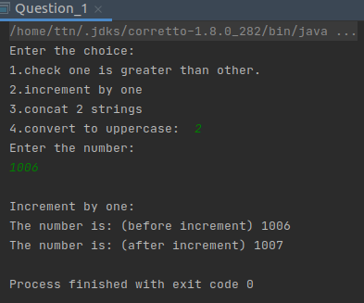

(3) Concatenation of 2 string Parameter (String , String ) Return (String)

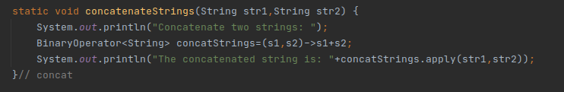

Output: 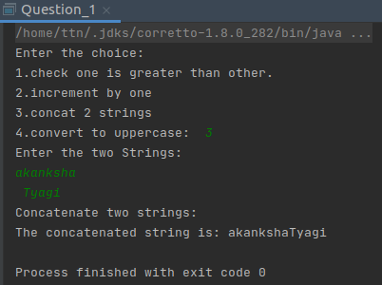

4) Convert a string to uppercase and return . Parameter (String) Return (String)

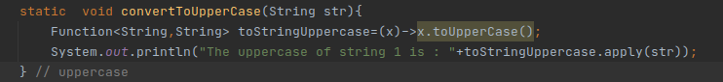

Output: 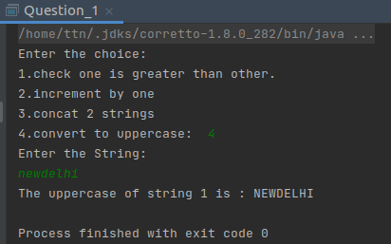

Q-2: Create a functional interface whose method takes 2 integers and return one integer.

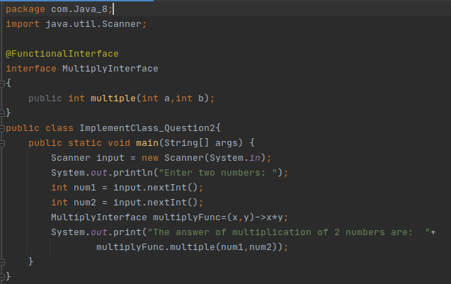

Output: 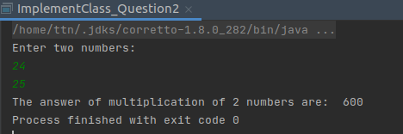

Q-3: Using (instance) Method reference create and apply add and subtract method and using (Static) Method reference create and apply multiplication method for the functional interface created.

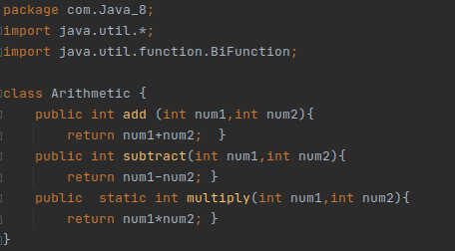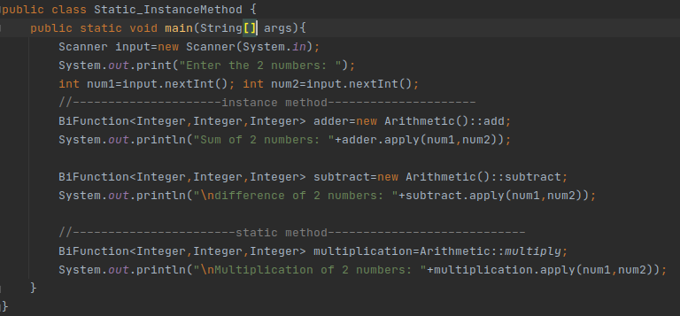

Output: 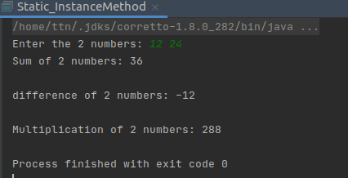

Q-4 Create an Employee Class with instance variables (String) name, (Integer)age, (String)city and get the instance of the Class using constructor reference.

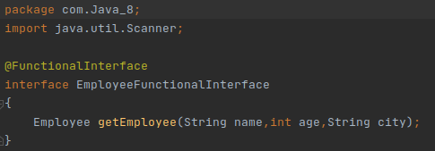 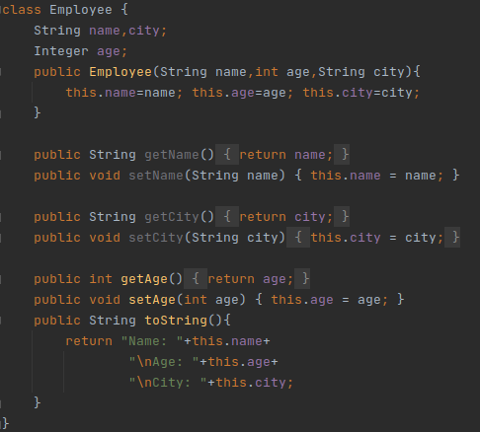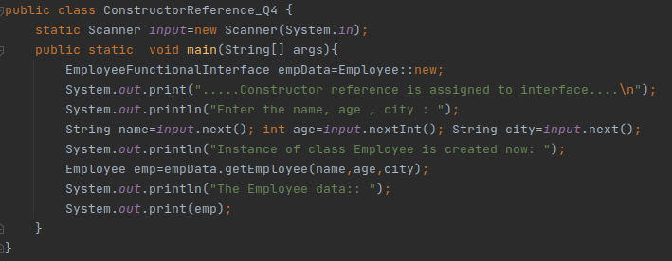

Output: 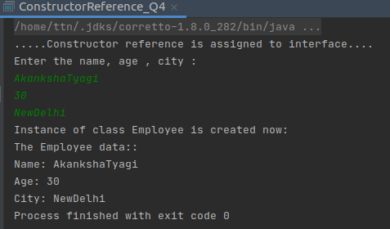

Q-5. Implement following functional interfaces from java.util.function using lambdas:

(1) Consumer

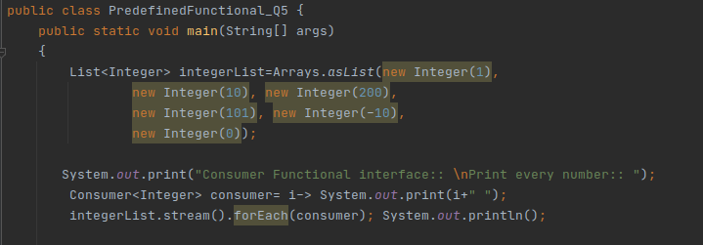

(2) Supplier

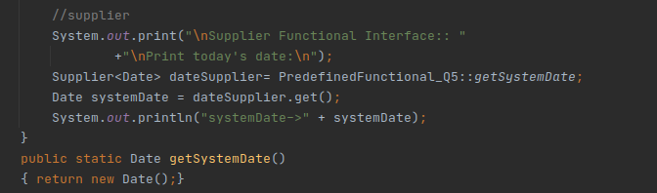

(3) Predicate

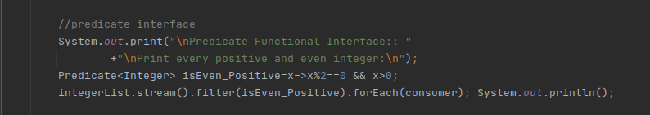

(4) Function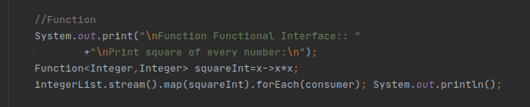

Output:

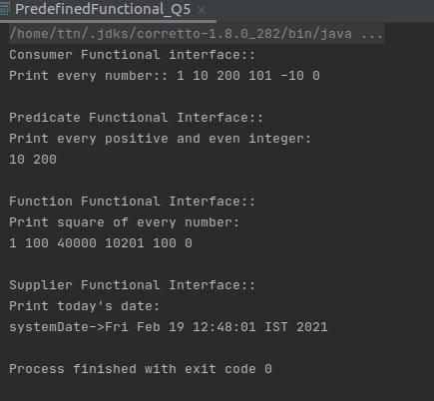

Q-6. Create and access default and static method of an interface.

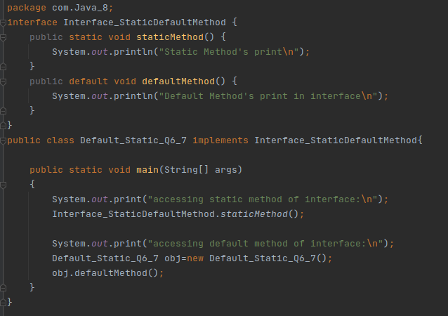

Output:

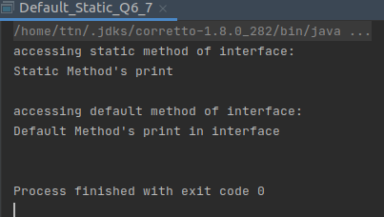

Q-7. Override the default method of the interface.

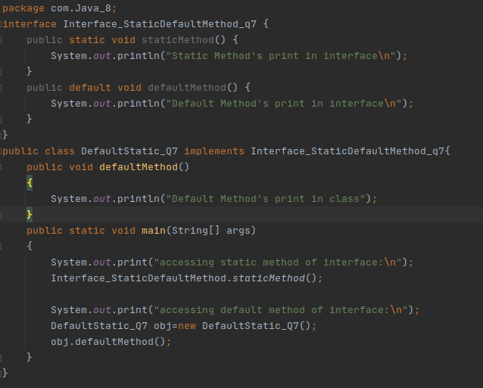

Output: 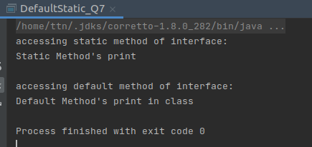

Q-8 Implement multiple inheritance with default method inside interface.

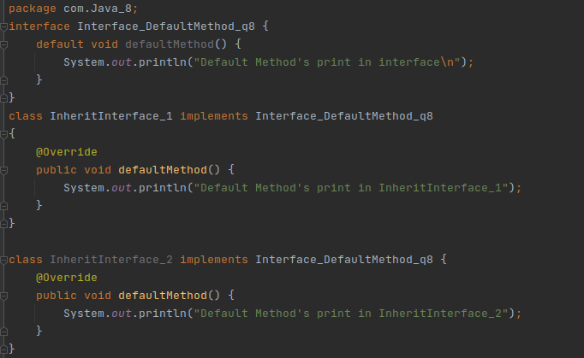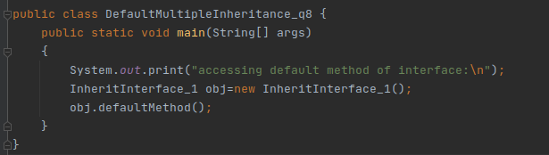

Output: 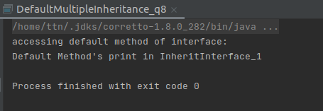

Q-9. Collect all the even numbers from an integer list.

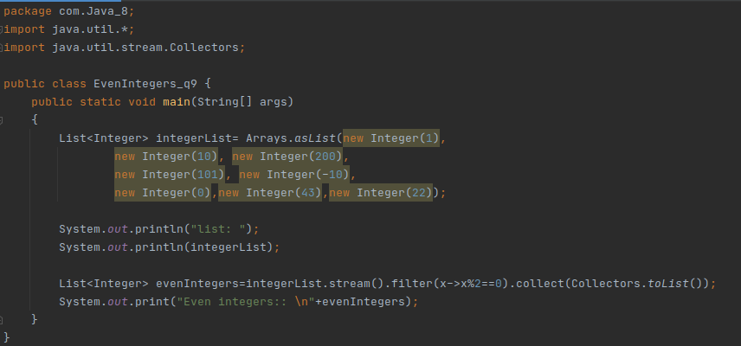

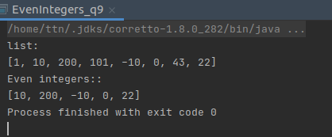

Q-10: Sum all the numbers greater than 5 in the integer list.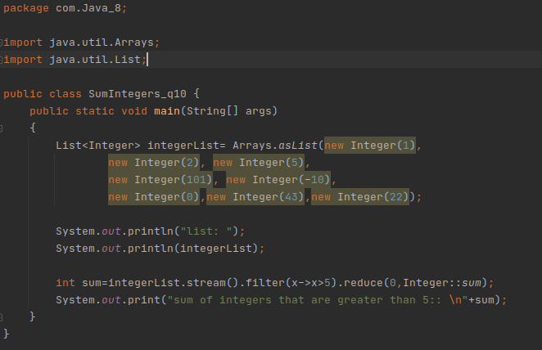

Output: 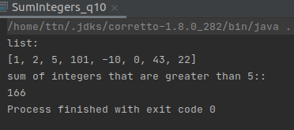

Q-11. Find average of the number inside integer list after doubling it.

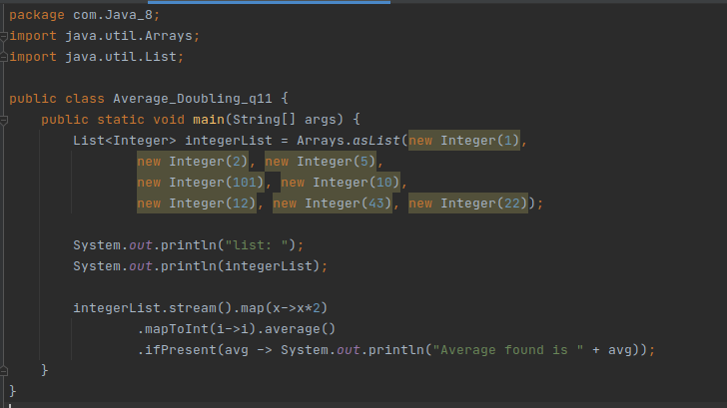

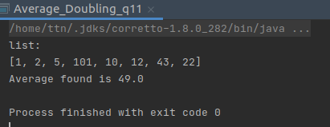

Q-12 Find the first even number in the integer list which is greater than 3.

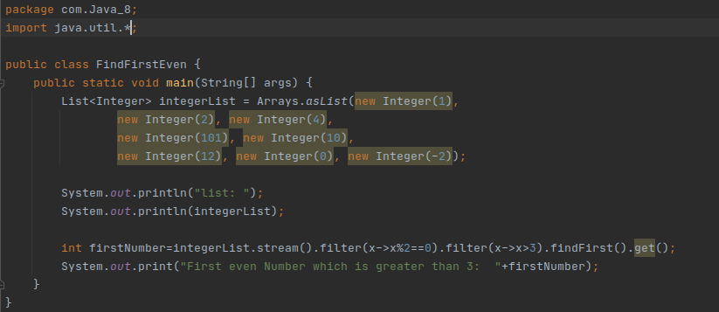

Output:

